**“My-Flix – A free movie watching platform”**

***A***

***Project Report***

*Created by Tarun Kumar while*

*Pursuing the degree*

**BACHELOR OF TECHNOLOGY**

**In**

**COMPUTER SCIENCE & ENGINEERING**

**With Specialization in**

**Business analytics and Optimization**

**From the University of Petroleum and energy sciences**

**CANDIDATE’S DECLARATION**

I hereby certify that the project work entitled **“My-Flix – A free movie watching platform”** in partial fulfillment of the requirements for the award of the Certificate of internship provided by IIT BHU, TechNex, and EI Systems and submitted to the instructor during the course of this internship, is an authentic record of my work carried out during a period from **27 June** **2021** to **26 July** **2022**. The links used for movies in this project are used only as demonstrative links and not actual movie locations and I don’t support plagiarism of any type, if there are some matching names it’s only because of a coincidence.

**Tarun Kumar**

This is to certify that the above statement made by the candidate is correct to the best of my knowledge.

Date: July 25, 2021

**ACKNOWLEDGEMENT**

We wish to express our deep gratitude to our guide **TechNex instructor**, for all advice, encouragement, and constant support he has given us throughout my project work. This work would not have been possible without his support and valuable suggestions.

I would like to thank all my friends for their help and constructive criticism during our project work. Finally, we have no words to express our sincere gratitude to our **parents** who have shown us this world and for every support, they have given us.

**ABSTRACT**

This is a fantastic and original concept for a web application. This program is meant to help moviegoers who are always rushing to the theatre to see new releases, no matter what actors or actresses are featured in them.

The application can be used by anyone, who wants to watch movies, series, and/or anime that are legally available for free over the internet without unknowingly paying for expensive subscriptions ultimately helping them better spend that money elsewhere. This application is developed in Visual Studio code for functioning back-end and front-end using HTML, CSS, and Bootstrap.

**TABLE OF CONTENTS**

|  |  |
| --- | --- |
| **Content** | **Page No.** |
| 1. **Introduction** | **4** |
| 1. **Objective** | **4 and 5** |
| 1. **Implementation**    1. Code    2. Output Screen | **5**  **5 to 10**  **11** |
| 1. **Conclusion and Future Scope** | **12** |
| 1. **References** | **12** |

1. **Introduction**

The movie industry is one of the fastest growing industries in today’s world and as with everything else COVID has also affected this industry in major proportions. One side of this is the boom in the online entertainment industry. Platforms like Netflix, Crunchyroll, and Amazon prime have skyrocketed during the worldwide lockdown and have also become unnecessarily expensive.

In this project, I have worked on designing and developing a user-interactive webpage named MyFlix that shows us different entertainment options such as popular movies, series, and anime that we can watch by simply clicking on the name of the show or movie we want to watch for free.

1. **Objective**

The objective of this project was to create a user-friendly webpage using the tips and tricks taught to us during the tenure of the web development internship and submit the project for completion of the internship.

I chose to implement the skills taught to us during the internship for developing a movie-watching webpage that helps users to explore different entertainment options such as popular movies, series, and anime for free.

1. **Implementation**

Design- I browsed through various popular websites in order to have an idea about the likes and dislikes of viewers on a user interface collecting data like the color of a website, popular fonts, dropdown options, etc.

Resources- I browsed through the internet for the official release images to insert on the web page and made sure that the size of all images is exactly the same.

Bootstrap- I downloaded and used bootstrap files to form the skeleton of the web page for better alignment and design of the web page.

Interactivity- The website is very interactive i.e. when we hover over the text it pops out and we can use the sections bar on the top of the page to navigate to a particular section of the project.

* 1. **Code:**

<!doctype html>

    <head>

        <title>My Flix</title>

        <link rel="stylesheet" href="bootstrap.min.css">

        <link rel="preconnect" href="https://fonts.googleapis.com">

<link rel="preconnect" href="https://fonts.googleapis.com">

<link rel="preconnect" href="https://fonts.gstatic.com" crossorigin>

<link href="https://fonts.googleapis.com/css2?family=Righteous&display=swap" rel="stylesheet">

    <style>

        a:hover

        {

            font-size: 20px;

        }

    </style>

    </head>

    <body style="background-color:black;">

        <nav class="navbar navbar-expand-lg navbar-dark bg-dark">

   <a class="navbar-brand" href="#">

    <img src="logo1.png" width="60" height="70" class="d-inline-block align-top" alt="">

  </a>

  <a class="navbar-brand" href="#" style="font-size: 30px;">My Flix</a>

  <button class="navbar-toggler" type="button" data-toggle="collapse" data-target="#navbarNavDropdown" aria-controls="navbarNavDropdown" aria-expanded="false" aria-label="Toggle navigation">

    <span class="navbar-toggler-icon"></span>

  </button>

    &nbsp;&nbsp;&nbsp;&nbsp;&nbsp;&nbsp;&nbsp;&nbsp;&nbsp;&nbsp;&nbsp;&nbsp;&nbsp;&nbsp;&nbsp;&nbsp;&nbsp;&nbsp;

  &nbsp;&nbsp;&nbsp;&nbsp;&nbsp;&nbsp;&nbsp;&nbsp;&nbsp;&nbsp;&nbsp;&nbsp;&nbsp;&nbsp;&nbsp;&nbsp;&nbsp;&nbsp;

  &nbsp;&nbsp;&nbsp;&nbsp;&nbsp;&nbsp;&nbsp;&nbsp;&nbsp;&nbsp;&nbsp;&nbsp;&nbsp;&nbsp;&nbsp;&nbsp;&nbsp;&nbsp;

  &nbsp;&nbsp;&nbsp;&nbsp;&nbsp;&nbsp;&nbsp;&nbsp;&nbsp;&nbsp;&nbsp;&nbsp;&nbsp;&nbsp;&nbsp;&nbsp;&nbsp;&nbsp;

  &nbsp;&nbsp;&nbsp;&nbsp;

  <div class="collapse navbar-collapse" id="navbarNavDropdown">

    <ul class="navbar-nav">

      <li class="nav-item active">

        <a class="nav-link" href="#" style="color: crimson;font-size: 25px;">Home </a>

      </li>&nbsp;&nbsp;&nbsp;&nbsp;&nbsp;&nbsp;

      <li class="nav-item">

        <a class="nav-link" href="#movie" style="color: crimson;font-size: 25px;">Movies</a>

      </li>&nbsp;&nbsp;&nbsp;&nbsp;&nbsp;&nbsp;

      <li class="nav-item">

        <a class="nav-link" href="#series" style="color: crimson;font-size: 25px;">Series</a>

      </li>&nbsp;&nbsp;&nbsp;&nbsp;&nbsp;&nbsp;

      <li class="nav-item">

        <a class="nav-link" href="#anime" style="color: crimson;font-size: 25px;">Anime</a>

      </li>&nbsp;&nbsp;&nbsp;&nbsp;&nbsp;&nbsp;

      <li class="nav-item dropdown">

        <a class="nav-link dropdown-toggle" href="#" id="navbarDropdownMenuLink" data-toggle="dropdown" aria-haspopup="true" aria-expanded="false"style="color: crimson;font-size: 25px;">

          Categories

        </a>

        <div class="dropdown-menu" aria-labelledby="navbarDropdownMenuLink">

          <a class="dropdown-item" href="#">Action</a>

          <a class="dropdown-item" href="#">Another action</a>

          <a class="dropdown-item" href="#">Something else here</a>

        </div>

      </li>

    </ul>

  </div>

</nav>

<br><br><br>

<h1 style="color: red;font-family: 'Righteous', serif;" id="movie">Movies</h1><br>

        <div class="container">

            <div class="row">

                <div class="col-sm-2">

                    <img src="1.jpg" width="200" height="300" class="img-thumbnail" alt="Cinque Terre">

                     <center><a href="https://www2.swatchseries.ru/movie/real-steel-4x9o" style="color: crimson;">Real steel</a></center>

                </div>

                <div class="col-sm-2">

                    <img src="2.jpeg" width="200" height="300" class="img-thumbnail" alt="Cinque Terre">

                     <center><a href="https://www1.swatchseries.ru/movie/alita-battle-angel-rjp5q" style="color: crimson;">Alita the battle Angel</a></center>

                </div>

                <div class="col-sm-2">

                    <img src="3.jpeg" width="200" height="300" class="img-thumbnail" alt="Cinque Terre">

                     <center><a href="https://www1.swatchseries.ru/movie/inception-zlzm" style="color: crimson;">Inception</a></center>

                </div>

                <div class="col-sm-2">

                    <img src="4.jpeg" width="200" height="300" class="img-thumbnail" alt="Cinque Terre">

                     <center><a href="https://www1.swatchseries.ru/movie/interstellar-kwj4" style="color: crimson;">Interstellar</a></center>

                </div>

                <div class="col-sm-2">

                    <img src="5.jpg" width="200" height="300" class="img-thumbnail" alt="Cinque Terre">

                     <center><a href="https://www1.swatchseries.ru/movie/mad-max-fury-road-zzm" style="color: crimson;">Mad max fury road</a></center>

                </div>

                <div class="col-sm-2">

                    <img src="6.jpeg" width="200" height="300" class="img-thumbnail" alt="Cinque Terre">

                     <center><a href="https://www1.swatchseries.ru/movie/the-maze-runner-v5v7m" style="color: crimson;">The Maze Runner</a></center>

                </div>

            </div>

        </div>

        <h1 style="color: red;font-family: 'Righteous', serif;" id="series">Series</h1><br>

        <div class="container">

            <div class="row">

                <div class="col-sm-2">

                    <img src="7.jpg" width="200" height="300" class="img-thumbnail" alt="Cinque Terre">

                     <center><a href="https://www1.swatchseries.ru/series/game-of-thrones-92p7q" style="color: crimson;">Game of thrones</a></center>

                </div>

                <div class="col-sm-2">

                    <img src="8.jpeg" width="200" height="300" class="img-thumbnail" alt="Cinque Terre">

                     <center><a href="https://www1.swatchseries.ru/series/the-vampire-diaries-4qvvo" style="color: crimson;">The vampire diaries</a></center>

                </div>

                <div class="col-sm-2">

                    <img src="9.jpeg" width="200" height="300" class="img-thumbnail" alt="Cinque Terre">

                     <center><a href="https://www1.swatchseries.ru/series/the-originals-7w8q1" style="color: crimson;">The Originals</a></center>

                </div>

                <div class="col-sm-2">

                    <img src="10.jpeg" width="200" height="300" class="img-thumbnail" alt="Cinque Terre">

                     <center><a href="https://www1.swatchseries.ru/series/sherlock-yq3xx" style="color: crimson;">Sherlock holmes</a></center>

                </div>

                <div class="col-sm-2">

                    <img src="11.jpeg" width="200" height="300" class="img-thumbnail" alt="Cinque Terre">

                     <center><a href="https://www2.swatchseries.ru/series/z-nation-5k6pq" style="color: crimson;">Z nation</a></center>

                </div>

                <div class="col-sm-2">

                    <img src="12.jpeg" width="200" height="300" class="img-thumbnail" alt="Cinque Terre">

                     <center><a href="https://www1.swatchseries.ru/series/peaky-blinders-2p9mq" style="color: crimson;">Peaky blinders</a></center>

                </div>

            </div>

        </div>

        <h1 style="color: red;font-family: 'Righteous', serif;" id="anime">Anime</h1><br>

        <div class="container">

            <div class="row">

                <div class="col-sm-2">

                    <img src="13.jpg" width="200" height="300" class="img-thumbnail" alt="Cinque Terre">

                     <center><a href="https://www1.swatchseries.ru/series/naruto-ykyp" style="color: crimson;">Naruto</a></center>

                </div>

                <div class="col-sm-2">

                    <img src="14.jpg" width="200" height="300" class="img-thumbnail" alt="Cinque Terre">

                     <center><a href="https://9anime.pw/watch/one-piece.ov8/ep-1" style="color: crimson;">One piece</a></center>

                </div>

                <div class="col-sm-2">

                    <img src="15.jpg" width="200" height="300" class="img-thumbnail" alt="Cinque Terre">

                     <center><a href="https://9anime.pw/watch/jujutsu-kaisen-tv.32n8/ep-1" style="color: crimson;">Jujutsu Kaisen</a></center>

                </div>

                <div class="col-sm-2">

                    <img src="16.jpg" width="200" height="300" class="img-thumbnail" alt="Cinque Terre">

                     <center><a href="https://9anime.pw/watch/demon-slayer-kimetsu-no-yaiba.6q67/ep-1" style="color: crimson;">Demon Slayer</a></center>

                </div>

                <div class="col-sm-2">

                    <img src="17.jpg" width="200" height="300" class="img-thumbnail" alt="Cinque Terre">

                     <center><a href="https://9anime.pw/watch/haikyu.rjqn" style="color: crimson;">Haikyu</a></center>

                </div>

                <div class="col-sm-2">

                    <img src="18.jpg" width="200" height="300" class="img-thumbnail" alt="Cinque Terre">

                     <center><a href="https://9anime.pw/watch/my-hero-academia.jvl2/ep-1" style="color: crimson;">My hero academia</a></center>

                </div>

            </div>

        </div>

    </body>

* 1. **Output:**

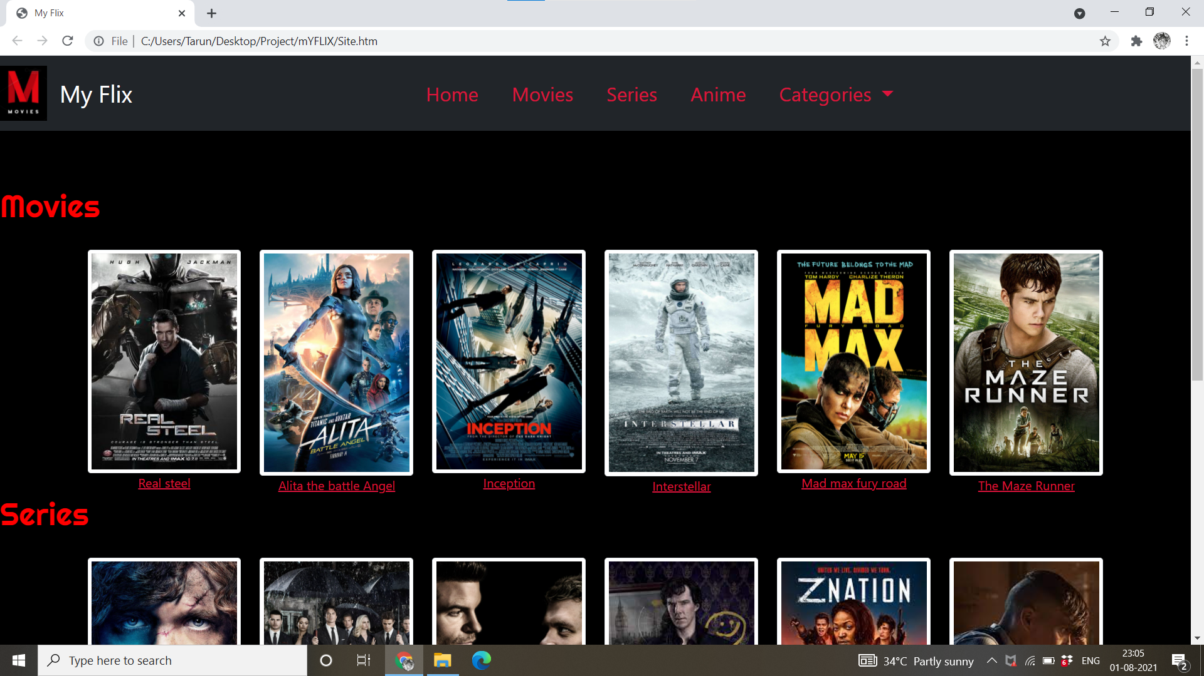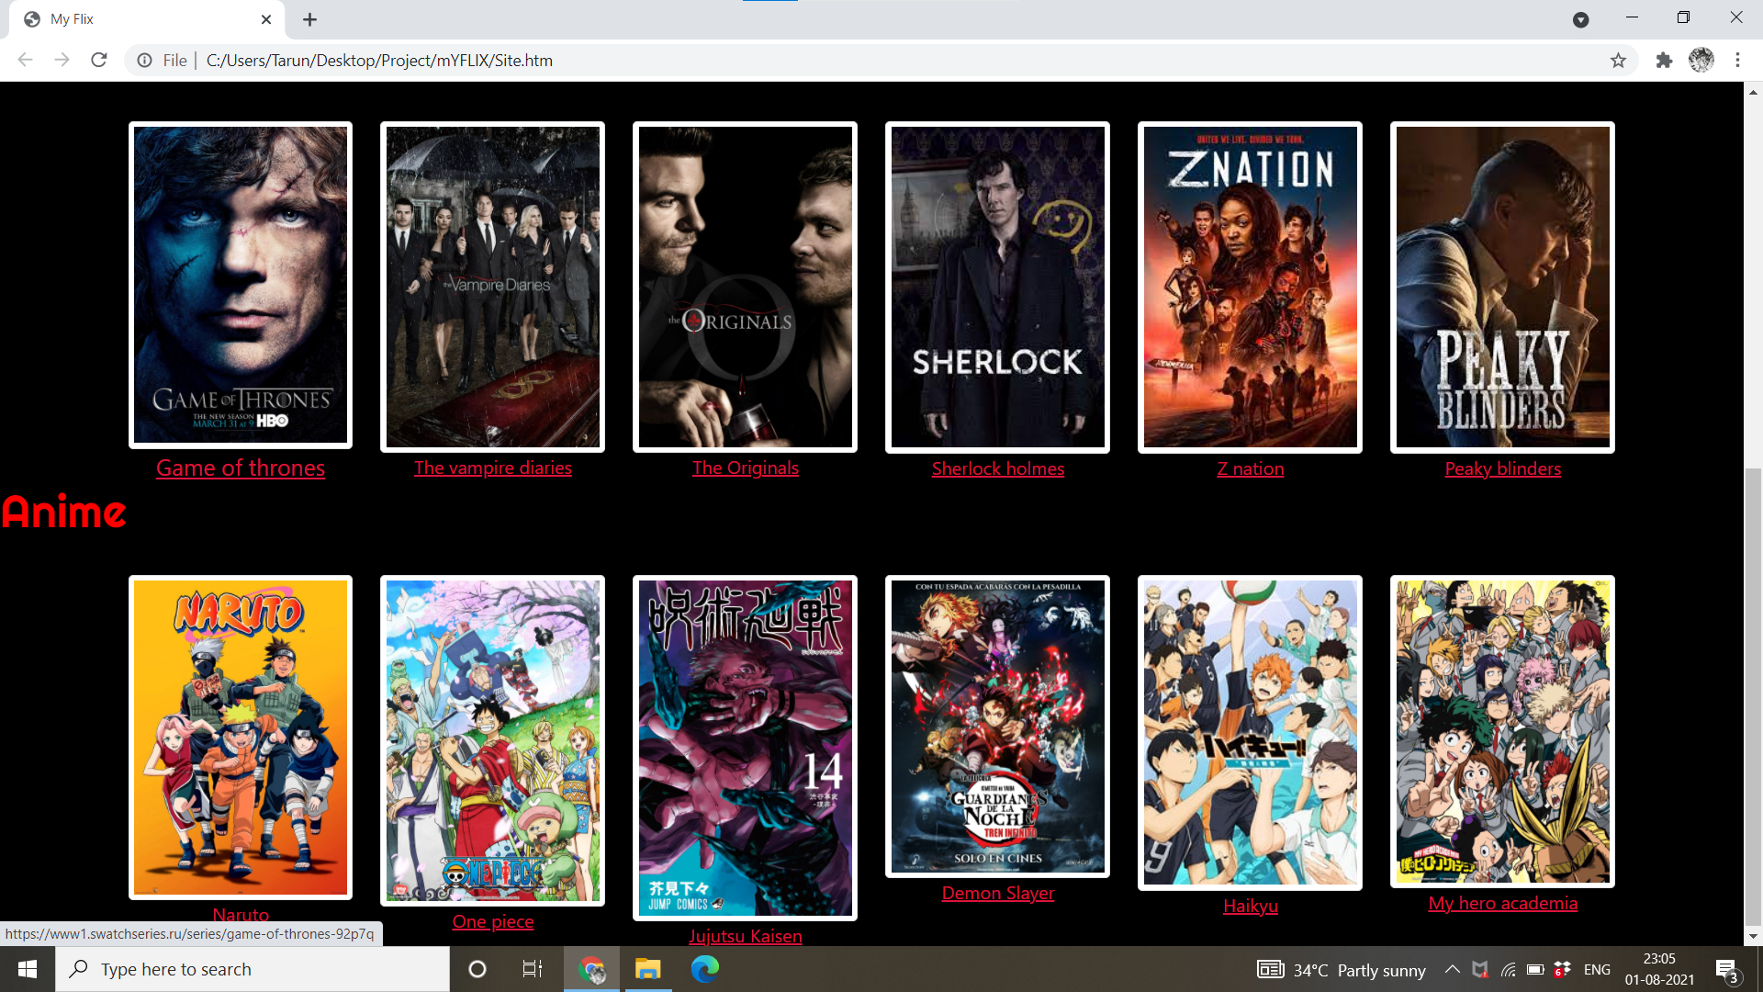

1. **Future Scope**

This project has a huge future scope as it is a prototype right now and it can grow into a full-blown website and can be integrated with different tools and its own database so that it doesn’t have to rely on external websites or links to function properly and people can enjoy free streaming legally.

1. **References**

[1] [www.google.com](http://www.google.com)

[2]www.9anime

[3]www.swatchseries